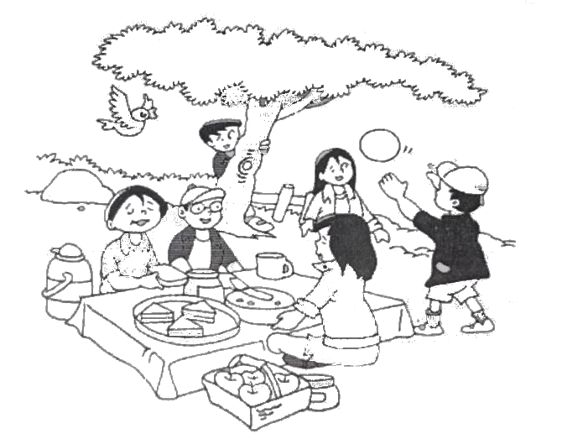

**drinking hiding flying playing eating sitting**

Father is

Mother is

Daughter is

Boy is

Bird is

Children are